Analysis of anthropogenic noise in urban environment
Pratyush R.Maharana

Abstract:

The purpose of this project is to demonstrate that it is possible to carry out audio measurements of spectrum characteristics and sound pressure levels of noise in urban areas, using commonly available smart phones.
A survey has been taken using the phyphox mobile app which has been developed by RWTH Aachen University. The data was taken between 8-Oct and 11nov .The area surveyed was R.K.Puram Sec-8 and Sec-7,New Delhi. Measurements of sound pressure levels and frequency spectrum were taken to determine the distribution of noise in the region. Frequency spectrums at different locations around this region were measured for a minimum of at least 1 minute. The audio spectrums were observed in the range from 20 Hz to 24 KHz. To check the adverse effects of noise pollution in urban environments sound recordings of bird vocalizations were analyzed. Sound recordings were also used to construct spectrograms to determine how much local bird vocal characteristics are affected by anthropogenic noise. The attenuation of noise by trees and other vegetation has also been qualitatively measured to check the hypotheses of this project.

We find that areas with trees do have significantly lower decibel levels as compared to other traffic prone areas and that man made noise does in fact fall within the range of most bird vocalizations, hence causing interference.
Since the data collection of this project is portable a follow-up survey encompassing a larger area is proposed for future. The effect of urban noise on animals especially birds and the attenuation of noise by trees are interesting projects on their own and will be further analysed in future.

Contents
Abstract: 2
Introduction: 3
Hypothesis: 4
Objective: Analysis of anthropogenic noise in urban area 4
Methodology: 4
Survey: 5
Case Study: 5
Observations and Data Collection: 6
Data analysis and interpretation 13
Results 15
Conclusion 17
Future scope 18
Acknowledgements 18
References 18

Introduction:
Noise pollution has been a major issue since the urbanization of cities started. With the advent of cars and the rapid increase in technology this problem has only aggravated. It had been sidelined as "not a real issue" for many decades. But now numerous studies have shown the link between prolonged exposure to noise and hypertension, sleep disturbance, heart disease and even cognitive impairment in children. The environmental effects are far reaching and are now a big concern as we move towards a sustainable future.
Environmental stressors such as noise and air pollution are becoming more and more important in our industrialized world and especially traffic noise from road, aircraft, and railway transportation represents a potential novel cardiovascular risk factor (Munzel 2014).
According to World Health Organization noise pollution is an "underestimated threat" that can cause "sleep disturbance, cardiovascular effects, poorer work and school performance, hearing impairment."
Noise needn't be audible to generate discomfort. Sounds lower than 20 Hz (infrasound) and sounds higher than 20 KHz(ultrasound) are although not audible to humans do have detrimental effects on our health.
Common and loud noises that might agitate you do have a negative impact on your health.
Researchers do correlate noise pollution with an increased risk of heart disease , coronary heart failure. Loud noises can also start the stress response that can aggravate health issues (Munzel 2014,Babisch et.al 2013)
Negative effect of ultrasound is related to the vestibular organ in the inner ear, manifested by headaches, dizziness, imbalance, nausea, sleepiness during the day or excessive fatigue.

To help minimize the effects of traffic noise, researchers need to understand the noise sources, how the sound propagates to nearby communities, and how to reduce noise levels at the source, during propagation, or at the receiving end.

Hypothesis:
- Trees and vegetation can attenuate human made noise
- Bird vocalization is affected by human made noise

Objective: Analysis of anthropogenic noise in urban area

Methodology:
Audio measurements were taken at different locations in the region encompassing Sec-7, Sec-8, Sec-9 R.K.Puram. Frequency spectrum analysis and sound pressure levels were observed using the phyphox app. The audio spectrums were taken for a minimum of at least 1 min.

Survey:
The area surveyed for noise measurements is the region of Sec-7, Sec-8, Sec-9 R.K.Puram. The data was taken between 8-Oct and 11/12 -nov.
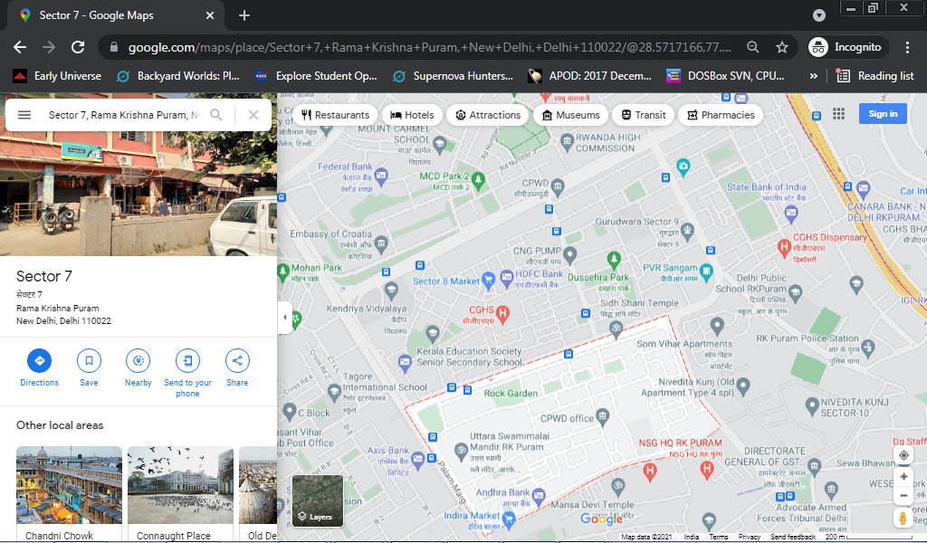

Case Study:
Local birds (Rose-Ringed Parakeet, Rock Pigeon, Common Myna ,Red Vented Bulbul ,Black Kite,) use calls and songs within the frequency range 1-20 KHz. Traffic noise and noise created by other human activites falling within this frequency range would cause interference. Although this requires the use of sensitive equipment representing the data in spectrograms and correlating the data with reference quality measurements done by other researchers we can distinguish the bird calls from each other and that from ambient noise.
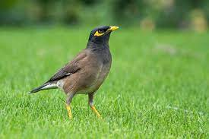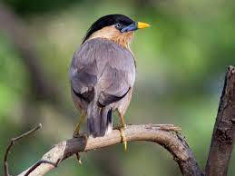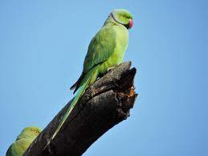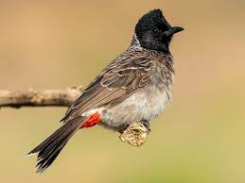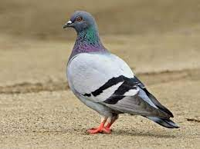
Local birds in Sector-7,8,9 R.K.Puram New Delhi
Common Mynah, Brahmin Mynah, Rose Ringed Parakeet, Black Kite, Red Vented Bulbul, Rock Pigeon

Observations and Data Collection:
Sound pressure level is a logarithmic measure of the effective pressure of a sound relative to a reference value. It is measured in decibels (dB) higher than a reference level. The reference sound pressure in air is 20 μPa (2×10⁻⁵ Pa), which is thought to be the human hearing threshold at a sound frequency of 1000 Hz.
A logarithmic scale to measure sound pressure level. A two-fold increase in sound energy will cause the sound pressure level to increase by 3 dB. A ten-fold increase in sound energy will cause the sound pressure level to increase by 10 dB, which is perceived as about twice as loud.
Fourier Transform of the audio spectrum and the sound pressure levels were done using the phyphox application while the spectrograms of the bird calls and voices were done using spek software.
We see that noise created by traffic has frequency components all over the spectrum with a constant buzz in the lower frequencies with occasional peaks in the higher frequencies.

- Frequency spectrums
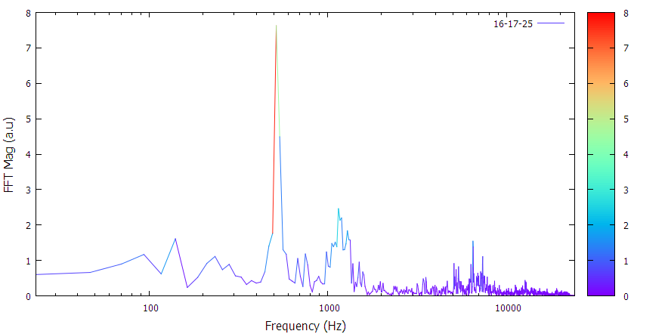
Figure I:Sector -8 Market
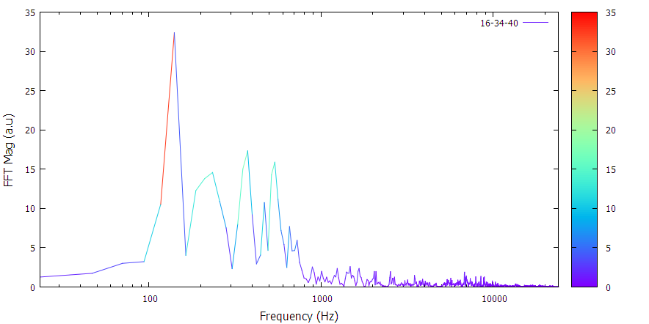
Figure II:K.V Sec-8, Bus Stop
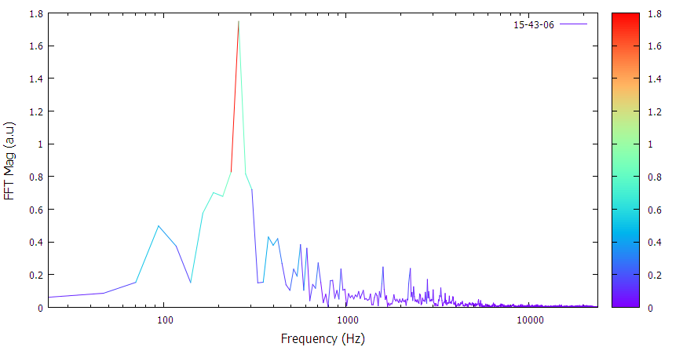
Figure III: Rock garden,Sec-7,R.K. Puram
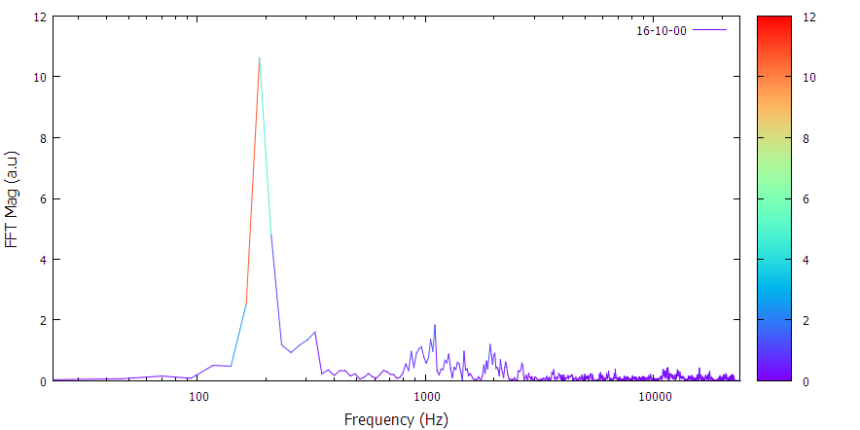
Figure IV: Near CGHS,Sec-8,R.K.Puram
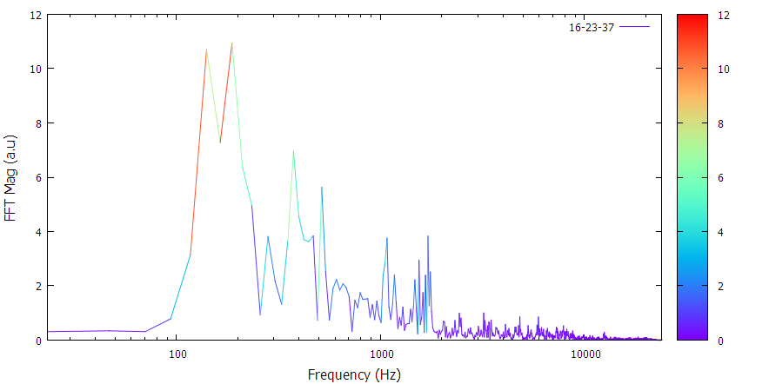
Figure V : sec 8 market
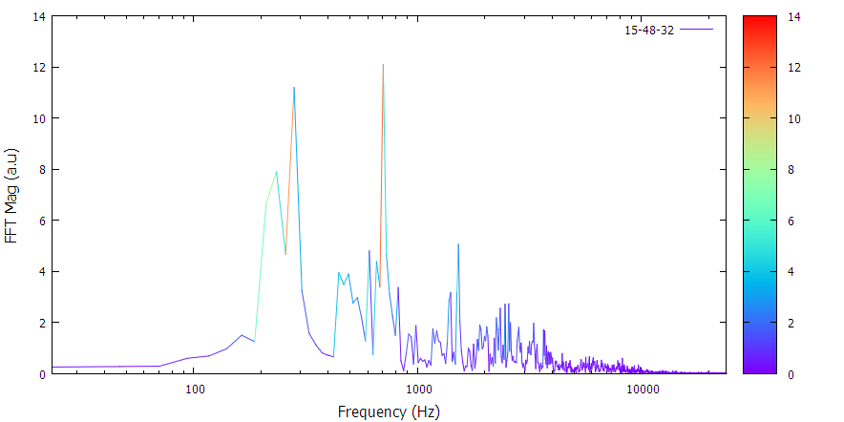
Figure VI: sec 7 bus stop
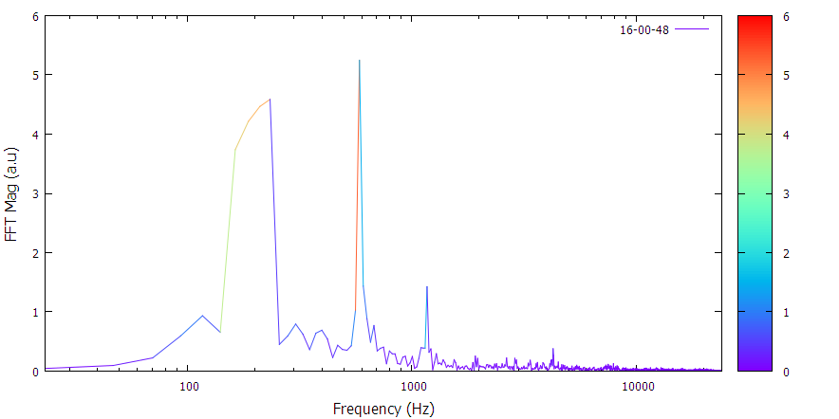
Figure VII: sec 8 bus stop
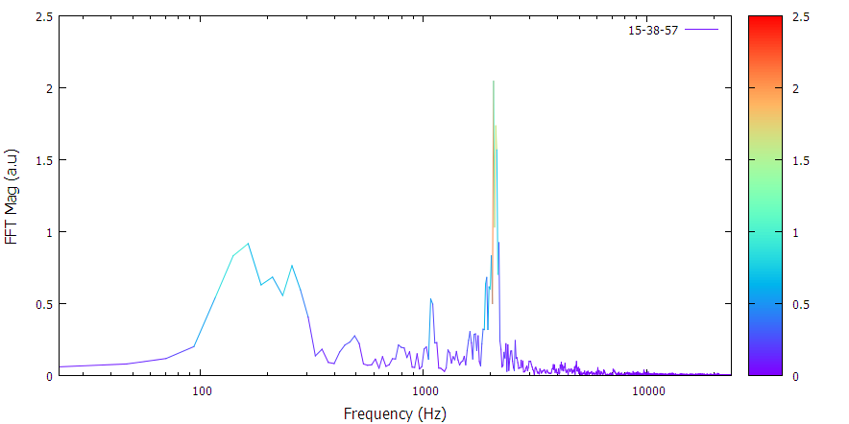
Figure VIII: Post Office,Sec-7
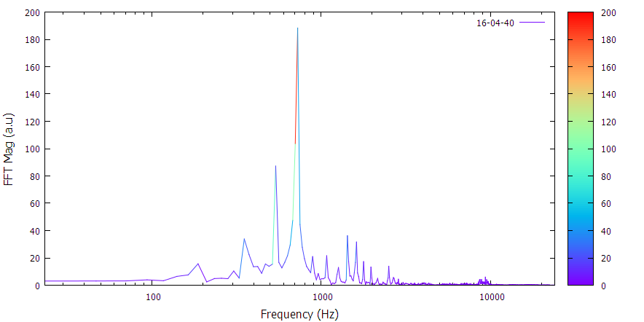
Figure IX Sec-8 gate
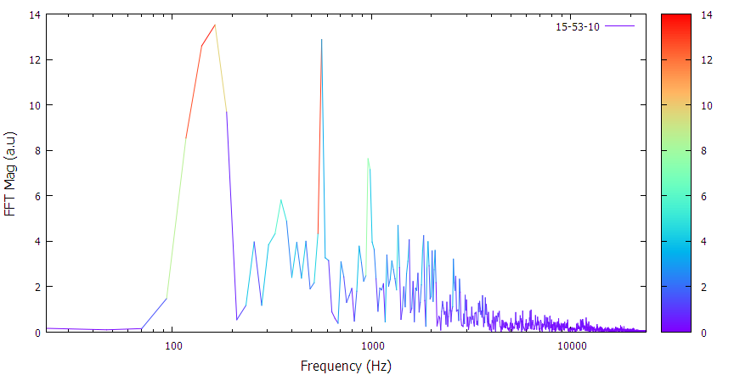
Figure X:Sec-7 main road

- Sound Pressure level measurements

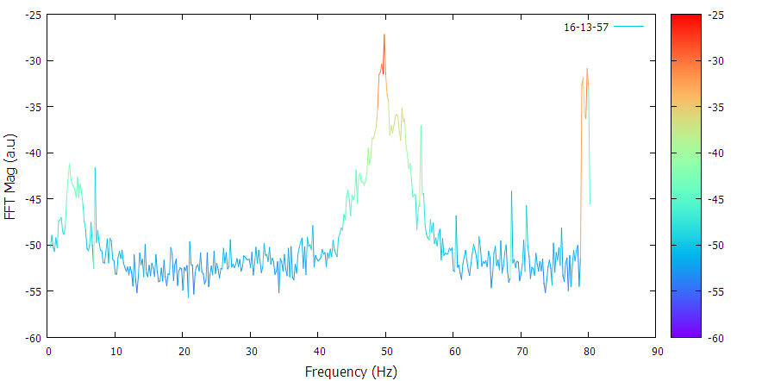
Figure XI:Sec 8 park
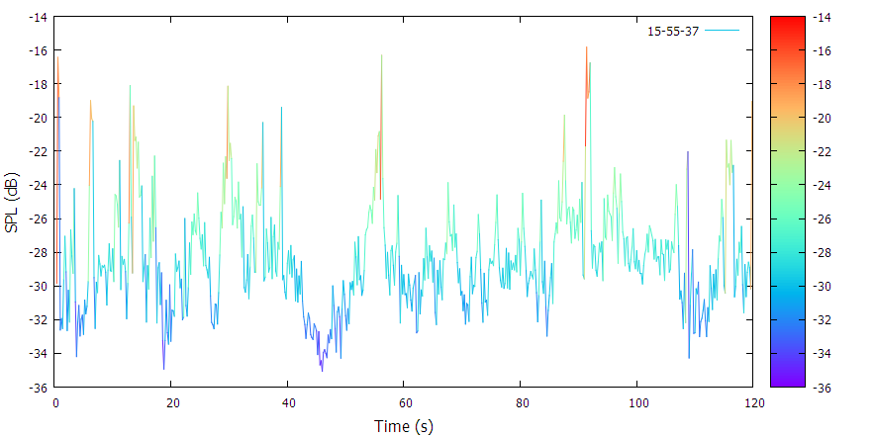
Figure XII:Sec 7 main road
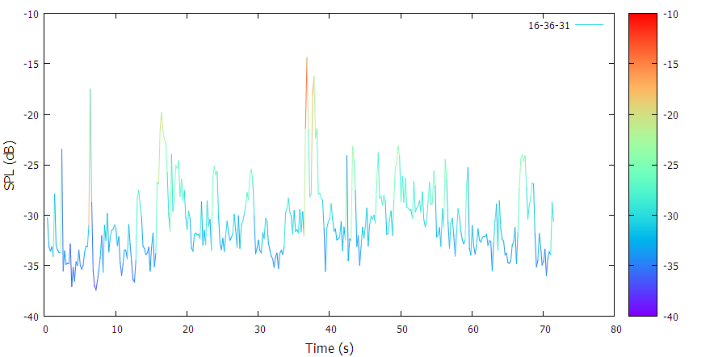
Figure XIII: Sec-8 KV Bus stop
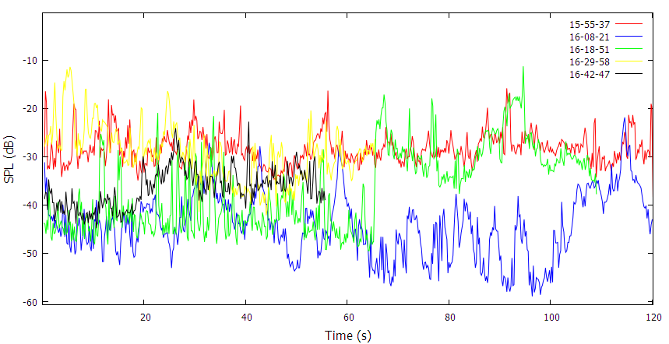
Figure XIV: Comparison of sound amplitudes at different locations (Sec-7 main road,CGHS Sec-8,Sec-8 Market,Sec-9 main road,Sec-8 KV

Data analysis and interpretation
Raw sound amplitude data measurements are not very informative.
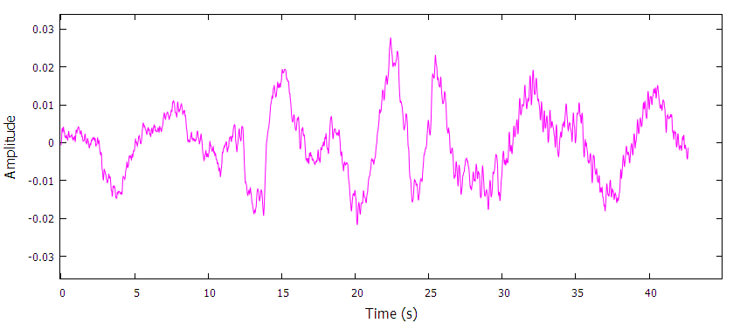
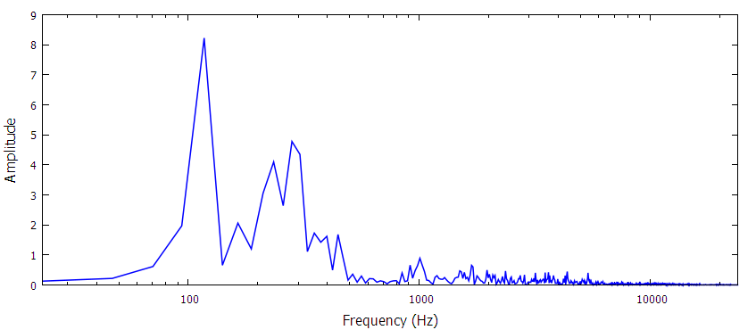
The raw data which is in the time domain just gives us information about the amplitude is not pretty informative .Like on a piano you can't just play the song by listening to it .You can do it however ,if you get your hands on the sheet music .How the notes go together ,how slow how fast the notes have to be played .This is akin to what the frequency domain representation of the audio data tells us .This is done taking the Fourier Transform of there audio signal .This tells us what different frequencies are present in the signal.
- Attenuation of noise by vegetation
Although there are impulsive sounds that may extend into higher frequency ranges in specific cases, most industrial machinery and vehicle engines generate sounds that are broadband and biased to relatively low frequencies (below 2.0 kHz).( Halfwerk et.al)


Figure XV: Measurements of Sound pressure levels at different locations
We see that the areas which are surrounded by vegetation have lower noise levels than that of areas near traffic roads.

Results
- Noise map
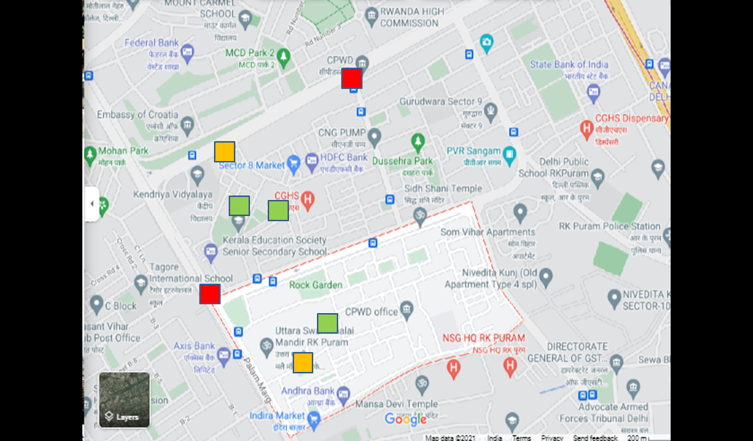
. From the audio measurements the given noise map was constructed.
The average sound pressure levels of the location were given a different colouring so as to display in the map.

- Interference of bird vocalizations by anthropogenic noise
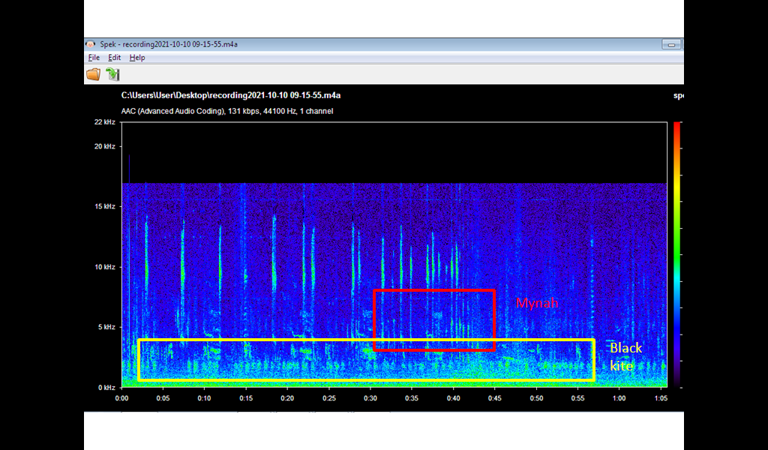
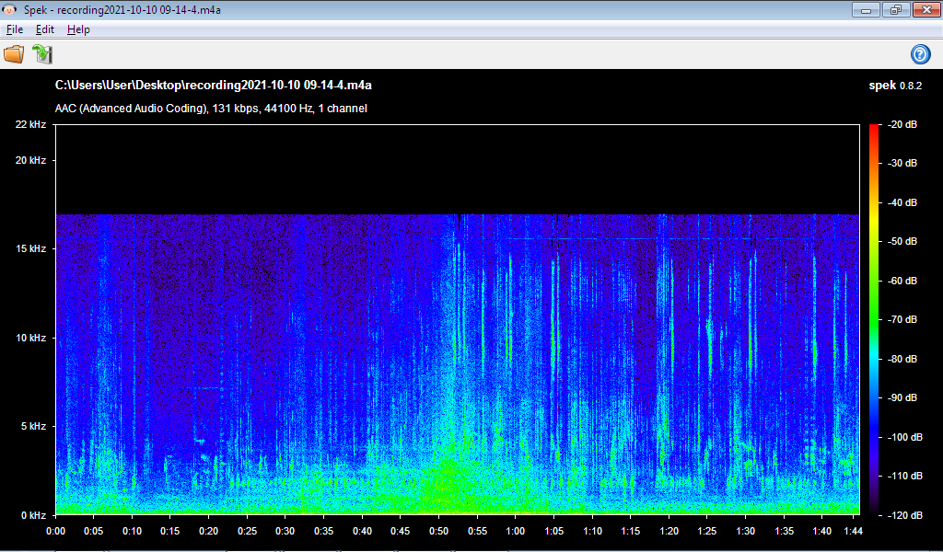
Figure XVI: Spectrograms of bird sounds

We see that most sources of anthropogenic noise pollute the spectrum at the lower frequencies and do interfere with the bird calls. Although most birds have a wide range of frequencies over which they communicate, human made noise in urban environments is a constant source of frequencies which overlap (in the plot above the green smudge shows the noise created by cars) the range of bird calls. There have been studies showcasing that urban birds sing at higher or lower frequencies than their rural counterparts so as to escape from interference. This requires much detailed recordings which was not possible currently with our recording medium.

- Attenuation of noise by vegetation

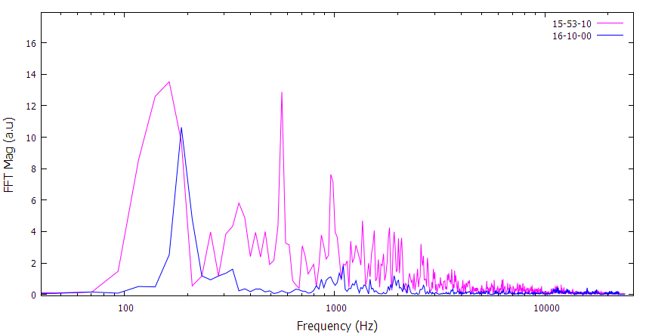
Figure XVII: Frequency Spectrum of Sec-7 main road and CGHS,Sec-8
The frequency spectrum of Sec-7,main road shows major peaks at the low frequencies and multiple peaks in the higher frequencies. While in contrast the spectrum taken near CGHS is mostly devoid of the high frequency components and the residual traffic noise from the main road is what gives the peak near 300 Hz. This goes in line with current research regarding how vegetation interacts with sound in a n urban environment (Ozer et.al 2008).

Conclusion
We see that noise created by traffic has frequency components all over the spectrum with a constant buzz in the lower frequencies with occasional peaks in the higher frequencies. This is of course a nuisance and is also detrimental to human and animal health. Urban noise also interferes with bird species that live in the surrounding area as their communication frequency range is swamped by anthropogenic noise. Sound attenuation by vegetation was also observed upon comparing sound pressure levels measurements at different locations with varying vegetation cover.
Pictures of Data observation
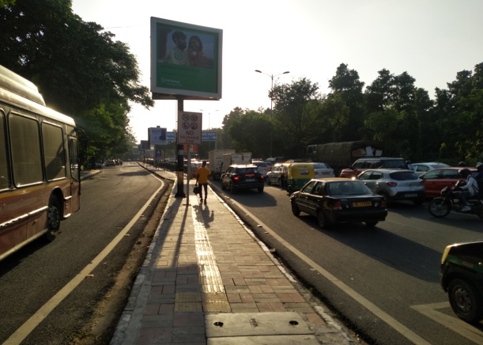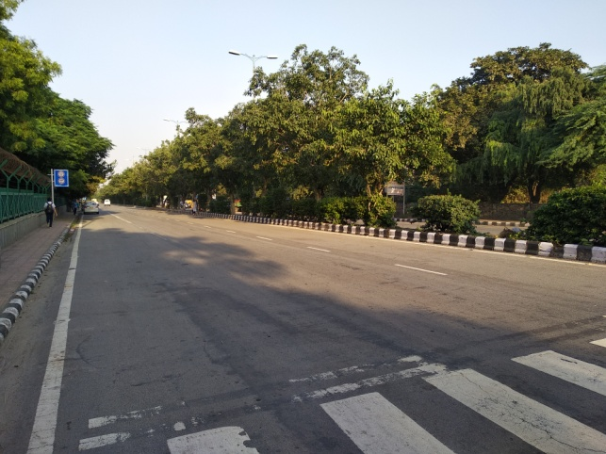

Future scope
A larger survey encompassing a larger area will be undertaken. A detailed analysis of the interference of human made noise on bird vocalization will be done.

Acknowledgements
We acknowledge the RWTH Aachen University for giving us access to the phyphox mobile application which was used to conduct the observation in this project.

References
Munzel T, Gori T, Babisch W, and Basner M. Cardiovascular effects of environmental noise exposure.Eur Heart J 35: 829–836, 2014.
Babisch W, Pershagen G, Selander J, Houthuijs D,Breugelmans O, Cadum E, Vigna-Taglianti F, Katsouyanni K, Haralabidis AS, Dimakopoulou K, Sourtzi P,Floud S, and Hansell AL. Noise annoyance—a modifier ofthe association between noise level and cardiovascular health? Sci Total Environ 452–453: 50–57, 2013.

Ozer, S., Irmak, M.A. & Yilmaz, H. Determination of roadside noise reduction effectiveness of Pinus sylvestris L. and Populus nigra L. in Erzurum, Turkey. Environ Monit Assess 144, 191–197 (2008). https://doi.org/10.1007/s10661-007-9978-6

